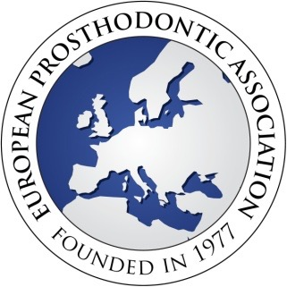

Title: Choose an item. Surname / Family name:

First name(s):

Dental / Specialist Qualifications (degrees / diplomas):

Address for correspondence:

City      Postcode:      Country:

Telephone number:

Email (essential) :

I wish to apply for membership of the European Prosthodontic Association. I am a member of my

National Prosthodontic Association which is:

(If not a member of a prosthodontic association, please include a brief Curriculum Vita that indicates your special interest in Prosthodontics.)

I agree to my name and email address being placed on the EPA members web page.

I consent to be contacted via mail or electronic methods.

Signature: Please sign here, print name or place an electronic signature

|  |  |
| --- | --- |
| **Membership options** | **Membership fees** |
| Membership of the EPA + subscription to the on-line version of the European Journal of Prosthodontics and Restorative Dentistry (4 issues yearly) | 80 Euros |

Please pay the membership fee (see below for payment method) and email this form to [epadental.acc@gmail.com](mailto:epadental.acc@gmail.com)

|  |  |  |
| --- | --- | --- |
| **Payment method** | **Payment to** | **Tick one** |
| **Bank Transfer** | Beneficiary name: European Prosthodontic Association  IBAN                   : GR4501727940005794103275177  SWIFT_BIC            : PIRBGRAA |  |
| **Paypal** | [epadental.acc@gmail.com](mailto:epadental.acc@gmail.com) |  |